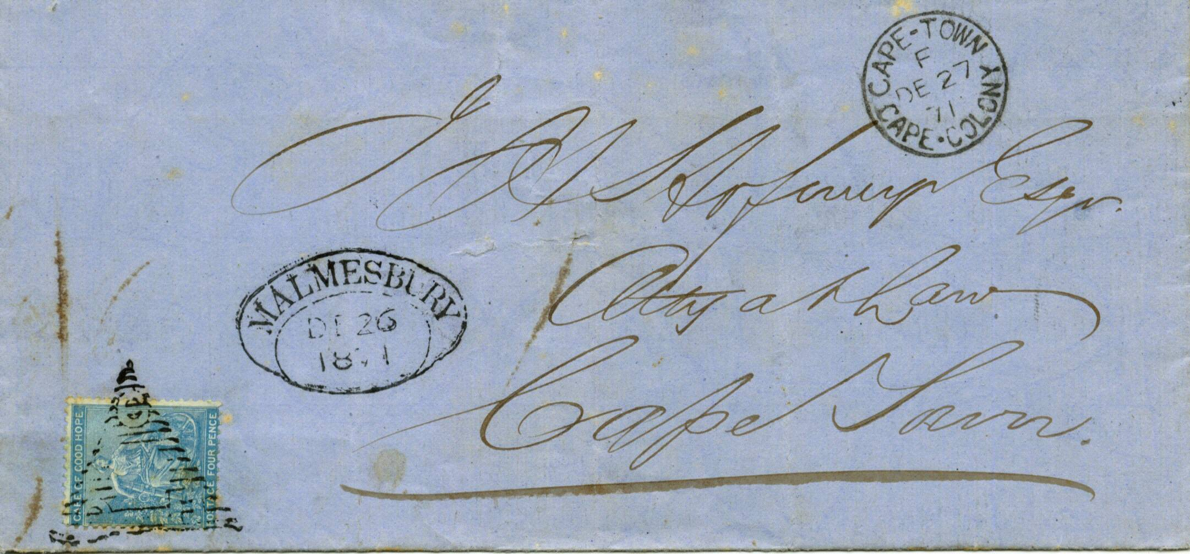
+

MALMESBURY TOWN OVAL HANDSTAMP

186 on H M Service pale blue outer letter sheet, from the Blanco post office showing a fine black strike of the “Blanco D.T.O.” of 12th January 1863. Cape Town receiving cds on front dated “JA 14 65”.

1871 wrapper from Malmesbury and addressed to Cape Town franked 4d seated Hope tied with small triangle obliterator. Adjacent “MALMESBURY D.T.O.” dated “DEC 26 71”. Also on front Cape Town cds dated “DEC 27 71”.

CAPE OF GOOD HOPE

DEVELOPENT OF POSTAL SERVICES

The Dated Town Oval

Handstamps of 1853

